Silvermark SS21 Hang Tag
所有産品使用山形咭設計
(雙面印刷掛卡兩張 – P.1封面&英文 P.2繁中&Silvermark的社文媒體帳號)

Style Code: 07021202, 07321202
Pathway Logo Tee
Pathway印花 Tee恤
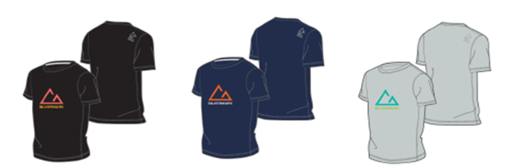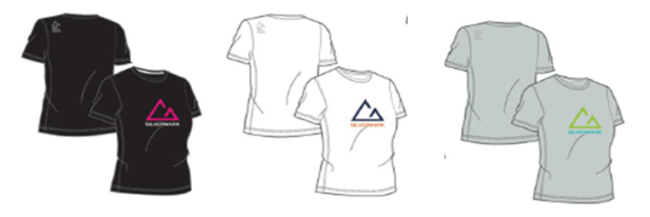
Features:
Crafted with premium moisture-wicking fabrics, this lightweight functional sports tee shirt is quick-drying and comfortable. Flatlock stitching and tapered fit both reduce excess fabrics and abrasion, minimizing the interference with your performance routine. The colour-block print logo on the chest is simple, but will make you stand out in the crowd. Designed to be worn as both a performance item as well as an essential daily item for styling to create various looks.
輕量功能性運動T恤，採用優質的吸濕排汗布料製成，速乾，舒適。平鎖針步和修身剪裁設計減少多餘的織物和穿著時的摩擦，提高日常穿著舒適度。正面簡約拼色印花，更顯活力個性。T恤可作功能性單品和日常單品穿著，搭配各種造型，是機能性休閒的必備單品。
- Moisture-wicking fabric keeps you cool and dry
- 吸濕速乾，保持身體和衣物乾爽

- Lightweight and comfortable
- 輕量舒適

- Colour-block print logo
- 拼色印花圖案

Style Code: 07021203, 07321203
Ridgeway Logo Tee
Ridgeway印花Tee恤
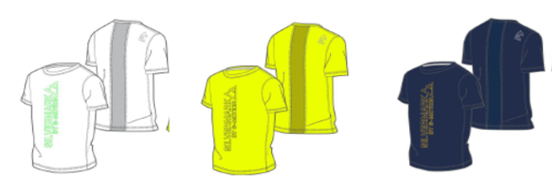
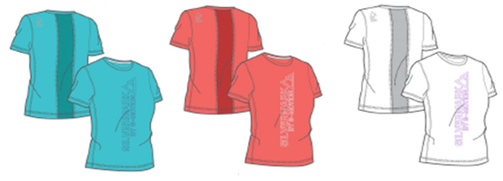
Features:
Crafted with premium moisture-wicking fabrics, this lightweight functional sports tee shirt is quick-drying and comfortable. Flatlock stitching and tapered fit both reduce excess fabrics and abrasion, minimizing the interference with your performance routine, while the mesh back panel enhances breathability. The bold colour-block print logo on the front panel is designed to allow the item to be worn as both a performance item as well as an essential daily item for styling to create various looks.
輕量功能性運動T恤，採用優質的吸濕排汗布料製成，速乾，舒適。平鎖針步和修身剪裁設計，減少了多餘的織物和穿著時的摩擦，提高日常穿著舒適度。後背網布加強透氣。正面的活力印花使T恤可作功能性單品和單品日常穿著，搭配各種造型，是機能性休閒的必備單品。
- Moisture-wicking fabric keeps you cool and dry
- 吸濕速乾，保持身體和衣物乾爽

- Mesh on back panel
- 後背網布
- Lightweight and comfortable
- 輕量舒適

- Colour-block print logo
- 拼色印花圖案

Style Code: 07021204, 07321204
Mural Cotton Tee
Mural棉質Tee恤
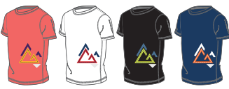

Features:
100%棉質圓領T恤，柔軟觸感，提高穿著舒適度，適合於炎熱夏天時穿著。正面Silvermark印花以民族方式演繹，令印花抽象而時尚，設計靈感來自傳統壁畫。
This crew neck tee shirt is made from 100% cotton, making it soft and comfortable to wear, especially during hot summer days. The tribal rendition of the Silvermark logo is inspired by traditional wall paintings, and makes for an abstract yet stylish all-over print.
- 100% cotton
- 100%棉質製成
- Soft and comfortable
- 柔軟舒適
- Colour-block print patterns
- 拼色印花圖案

Style Code: 07021205, 07321205
Oceania cotton tee
Oceania棉質Tee恤
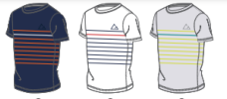
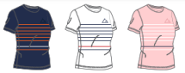

Features:
Inspired by the Breton striped jerseys used as the official uniform in the French navy, the timeless Oceania crew neck border tee shirt is made from 100% cotton, making it soft and comfortable to wear, especially during hot summer days.
設計靈感受法國海軍的不列塔尼條紋針織制服啟發。經典簡約的Oceania圓領條紋Tee恤，採用100%棉質製成，柔軟舒適，適合於炎熱夏天時穿著。
- 100% cotton
- 100%棉質製成
- Soft and comfortable
- 柔軟舒適

- Colour-block and Breton stripe design
- 拼色不列塔尼條紋條紋設計

Style Code: 07321206
Lagoon women’s performance top
Lagoon女裝功能性上衣
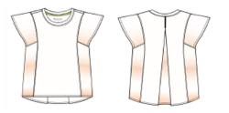

Features:
Adopting an A-line design for a soft, flowy fit with draped shoulder panels crafted from marble-inspired printed poly fabrics to enhance the sense of elegance, you could almost forget that this a serious performance top. The back slit, mesh panels and moisture-wicking fabrics all enhance airflow and cool comfort. To complete the outfit for sports, style with your favourite sports bra, or wear it over your most comfortable camisole for a sports-inspired casual look in the summer to transit between the city and the outdoors effortlessly.
採用A型設計，剪裁流暢而柔軟。垂肩部份，由大理石風格啟發的印花聚酯織維料製成，提升優雅感，您幾乎會忘記這是一款機能性出色的上衣。上衣採用吸濕排汗布料和網布製成，配上背部的開衩，提升透氣和涼爽的舒適感。使整體造型更完整，可配搭運動內衣或舒適的背心，打造運動休閒的造型，輕鬆穿梭於都市與戶外之間。
- Back slit, side mesh panels and moisture-wicking fabrics keep you cool and dry
- 吸濕速乾，保持身體和衣物乾爽
- Specialized marble-inspired print design
- 受大理石風格啟發的獨特印花

- Lightweight and comfortable
- 輕量舒適

Style Code: 07101201, 07401201
Reef water-repellent utility shorts
Reef防潑水功能性短褲
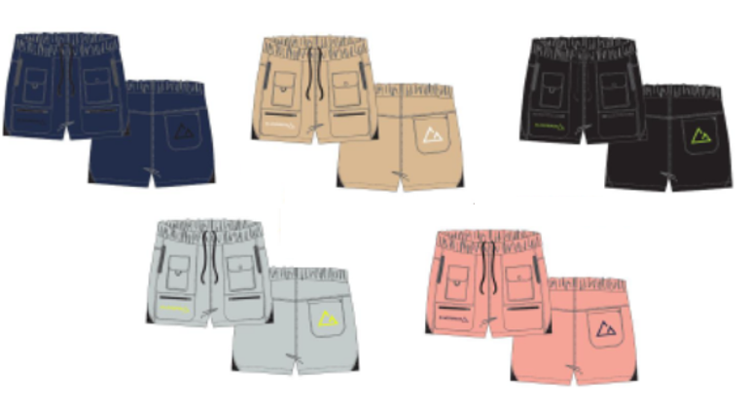
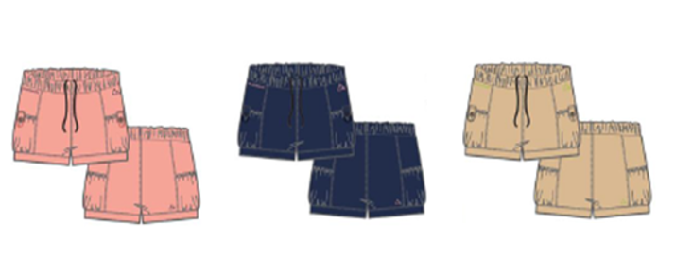
Features:
Function meets fashion! The fitted Silvermark Utility Shorts are made from ultralight crinkle-woven fabric for a soft, silky feel. They also feature a variety of zipper and flap pockets for extra convenient storage – coupled with the water-repellent capabilities, this item is ideal for sports and outdoor adventures.
當功能性遇上時尚！貼身剪裁的Silvermark機能短褲由超輕量皺紋織物製成，柔軟絲滑。短褲具有各種拉鏈袋和翻蓋袋，方便收納個人物品。配有防潑水功能，是運動和戶外探險的理想之選。

- W/R water-repellent function
- W/R防潑水功能
- Elastic waistband design for easy adjustment
- 橡筋褲腰採用抽繩設計，可輕鬆調節鬆緊，提高穿著舒適度。

- Multiple flap and zip pocket design for enhanced storage
- 具有多個拉鏈和翻蓋式口袋，方便收納個人物品。

- Lightweight and comfortable
- 輕量舒適

--- THE END ---

